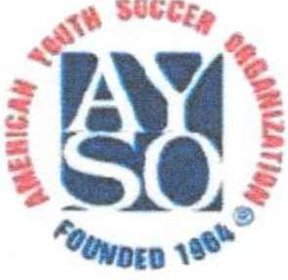
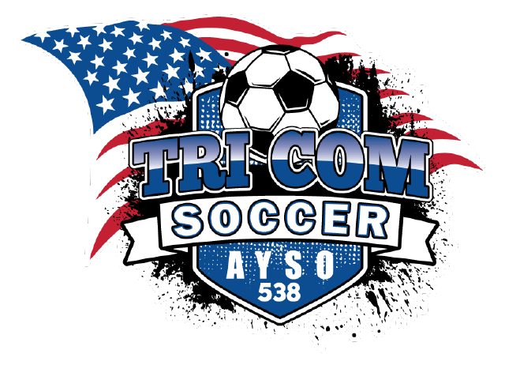
American Youth Soccer Organization
a nonprofit corporation dedicated to youth soccer
everyone plays.

To: Whom it may concern
From: Mike Bryant, Regional Commissioner AYSO Region 538
Subject: Support of our local Soccer Region

This letter is to request an Individual, Business or Corporate Partnership to support our local Volunteers & Players of AYSO Region 538. American Youth Soccer Organization (AYSO) is a non-profit organization founded in 1964 to promote the game of soccer to children in the United States.

Region 538 serves the communities of Phelan, Pinon Hills, Wrightwood, Baldy Mesa, Oak Hills, West Cajon Valley & also Summit Valley. These communities are primarily what are often referred to as Bedroom Communities.

What I’m asking for is for your business to join us in being successful for the upcoming Fall Season. Obviously, any means of support would be greatly appreciated. Your funds will be used to greatly improve our service delivery & will help to enrich the lives of our local children.

I hope we can form a partnership between our Region & your business. Our other option is to raise our Registration Fees & recoup the funds, which I’m desperately looking to avoid.

Thank you for your time. Please do not hesitate to contact me with any questions, comments, or concerns.

AYSO Tax Deductible Code 501(c)(3): 95-6205398

Mike Bryant, AYSO Tri-Communities Soccer Commissioner
4458 Highland Road, Phelan CA 92371
ayso538commissioner@gmail.com
760-963-6582

Sponsorship Form:

Complete & mail with a check or commodity amount to:

AYSO Region 538
Attn: Commissioner Mike &/or Crysta Stern
4458 Highland Rd
Phelan CA 92371

Business, Group, or Individual Name: ________________________________________________

Website: ___________________________________________________________

Email address: ___________________________________________________________

Physical Address: ___________________________________________________________

Telephone Number: ___________________________________________________________

Contact Person: ___________________________________________________________

Commodity amount (for Supporters providing material items):

_________________________________________________________________

Coach's Name (if applicable):

______________________________________________________

Official Use Only:

Date/Time Received:
Check No.
Team Name, # or Coach Name

